Declaration

We here by declare that the Mini Project Report entitled “DIABETES PREDICTION USING MACHINE LEARNING”
Submitted by us in partial fulfillment of the requirements for
the award of the degree of Bachelor of Technology in Computer Science & Information Technology.
From Dronacharya Group of Institutions,Greater Noida,is an authentic work carried out by us.
This project work has not been submitted by us for the award of any other degree or diploma.

Date: 15/11/2025 Place: Greater Noida

Krishna Sharma (Roll no:2302300110059)
Nikit Kumar (Roll no : 2302300110070) Naman Phuloria (Roll no:2302300110067)
Nitin Kumar (Roll no : 2302300110071)

Certificate

This is to certify that the Mini Project Report entitled
“DIABETES PREDICTION USING MACHINE
LEARNING”
Submitted by -:
Krishna Sharma (Roll no:2302300110059) Nikit Kumar (Roll no: 2302300110070) Naman Phuloria (Roll no:2302300110067) Nitin Kumar (Roll no: 2302300110071)

In partial fulfilment for the award of the degree of Bachelor
of Technology in Computer Science & Information Technology From Dronacharya Group of Institutions, Greater Noida,
is a Bona fide work carried out under my guidance.

The work embodied in this report has not been submitted to any Other University or Institution for the award of any degree or diploma.

Project Guide: Shekhar Tyagi

Acknowledgement

We are greatly in debted to our project guide Mr.Shekhar Tyagi For his able guidance throughout the course of this work.It has been an altogether difference experience to work with him and
We would like to Thank him for his help , suggestions and
numerious decisions.
We gladly take this opportunity to thank Mr.ShekharTyagi for providing Facility during progress of project,also,for his kindly help,guidance and inspiration.
Last but not least we are also thankful to all those who help directly or indirectly to develop thus project and complete it successfully with Deep Reverence,

Krishna Sharma (Roll no:2302300110059) Nikit Kumar (Roll no: 2302300110070) NamanPhuloria (Roll no:2302300110067)
Nitin Kumar (Roll no: 2302300110071)

Abstract
Diabetes is a chronic disease with the potential to cause a world wide health care crisis. According top international diabetes federation 382 million people are living with diabetes across the whole world by 2035, this will be doubled as 592 million diabetes mellitus or imply diabetes is a disease caused due to the increase level of blood glucose. Various traditional methods,based on physical and chemical tests are available for diagnosing
Diabetes. However early prediction on diabetes quite challaenging task for medical practitioners due to complex inter dependence on various factors as diabetes affects human organs such as kidney,eye,nerve,foot,heart,etc.
Data science method have the potential to benefit others scientific field by shedding new light on common questions one such task is to help prediction on medical data.
Machine learning is an emerging scientific field in data science dealing with the ways in which machine learns from experience.The aim of this project is to develop a system which can perform early prediction of diabetes for a patient with a higher accuracy by combining the result of different machine learning techniques.
This Project aims to predict diabetes via Three different supervised machine learning method including : SVM , Logistic Regression , KNN.

Table of Contents
- Introduction 7
  - Background
  - Problem Staement
  - Objective
  - Scope
  - Limitation

- System Reqirement and Design 10
2.1. Hardware Requirements
2.2. Software Requirements
2.3. System Architecture
2.4. Flowchart
2.5. UML Diagram

- Implementation 14
3.1. Tools &Technologies Used
3.2. Proposed Methodology

- Model Evaluation 20
4.1. Model Selection and Training
4.2. Accuracy
4.3. Precision, Recall, F-1Score

- Prediction 22
- Result & Discussion 23
- Conclusion &Future Work 24-25
- Homepage, Diabetic or Non Diabetic Prediction 26-28
(Frontend Result)
- References(APA Style) 29

List of Figures & Tables
  - System Architecture diagram. 11
  - Flow chart diagram of Machine Learning 12
  - UML Case diagram 13
  - Tool &Technologies Used Table 14
  - Diabetes Prediction Dataset Attributes Table 16
  - Diabetes Prediction dataset Table 17
  - Distribution of dataset for diabetes/Non-diabetes Patient 18
  - Data Pre-Processing 19
  - Accuracy 21
  - Precision,Recall,F-1ScoreTable 21
  - Prediction Output for diabetic/Non-diabetic Patient 22
  - Future Steps For Machine Learning Models 25
  - Homepage of Diabetes Prediction Model 26
  - Chances of Having Diabetes 27
  - Non Diabetes(You are Safe) 28

Chapter-1 Introduction
1.1 Background
All around the are numerous ceaseless infections that are boundless
in evolved and developing nations. One of such sickness is diabetes.
Diabetes is a metabolic issue that causes blood sugar by creating a significant measure of insulin in the human body or by producing a
little measure of insulin. Diabetes is perhaps the deadliest sickness
on the planet. It is not just a malady yet, also a maker of different
sorts of sicknesses like A coronary failure,visual deficiency, kidney ailments and nerve harm, and so on. Subsequently.

The identification of such chronic metabolic tab beginning period
could help specialists around the globe in forestalling loss of human
life.Presently, with the ascent of machine learning, AI, and neural systems, and their application in various domains[1,2]we may have
the option to find an answer for this issue. ML strategies and neural systems help scientist to find new realities from existing well-being- related informational indexes, which may help in ailment supervision and detection.

The current work iscompleted utilizing the Pima Indians Diabetes Database.The point of this framework is to make an ML model, which can anticipate with precision the likelihood or the odds of a patient being diabetic.The ordinary distinguishing process for the location of diabetes is that the patient needs to visit a symptomatic focus. One of the key issues of bio-informatics examination is to achieve precise outcomes from the information. Human mistakes
or various laborator tests can entangle the procedure of identification of the disease.
This model can foresee whether the patient has diabetes or not, aiding specialists to ensure that the patient in need of clinical consideration can get it on schedule and also help anticipate the loss of human lives.

Cause of Diabetes

Genetic factors are the main cause of diabetes. It is caused by at least two mutant genes in the chromosome 6, the chromosome that affects there sponse of the body to various antigens.Viral infection may also influence the occurrence of type 1 and type 2 diabetes. Studies have shown that infection with viruses such as rubella,Coxsa, ckiev irus, mumps, hepatitis B virus, and cytomegalovirus increase the risk of developing diabetes.

Types of Diabetes:

Type1
Type1 diabetes means that the immune system is compromised and
the cells fail to produce insulin in sufficient amounts. There are no eloquent studies that prove the causes of type 1 diabetes and there are currently no known methods of prevention.
Type2
Type-2 diabetes means that the cells produce a low quantity of insulin or the body can’t use the insulin correctly.This is the most common type of diabetes, thus affecting 90 % of persons diagnosed with diabetes.
It is caused by both genetic factors and the manner offliving.
Data mining and machine learning have been developing , reliable, supporting tools in the medical domain in recent years. The data mining method is used to pre-process and select the relevant features from the healthcare data, and the machine learning method helps automate diabetes prediction [14]. Data mining and machine learning algorithms can help identify the hidden pattern of data using the cutting-edge method; hence are liable accuracy decision is possible. Data Mining is a process where several techniques are involved,
Including machine learning,statistics,and database system to discover
a pattern from the massive amount of dataset [15]. According to Nvidia: Machine learnings various algorithms to learn from the parsed data and make predictions

Problem Statement
The increasing prevalence of diabetes necessitates the development of efficient prediction models. Current methods lack real – time accessibility and often fail to identify individuals at risk early enough for preventive measures.This project aims to develop a machine learning based system that can predict the likelihood of diabetes in individuals based on various health parameter

Objective
    - To collect and process a dataset containing relevant health features.
    - The implement and compare multiple machine learning algorithm for diabetes prediction.
    - To evaluate the performance of the semode using appropriate metrics.
    - To develop a user friendly interface for real-time predictions.

Scope
The project will focus on prediction Type – 2 Diabetes using a dataset that includes feature such as age , BMI , glucose levels , blood pressure and insulin levels.The scope is limited to the use of supervised learning algorithms and does not extend to deep learning technique or real- time sensor data integration.

1.5 Limitation

    - Our data set are have around 768 data of womens.
    - Model Accuracy by using svm is 78 %.
    - Moderate Accuracy because of the dataset quantity.
    - Quality of data is Moderate (Most of the data containing Insulin level =0).
    - Voice / interface accuracy : If voice input issuse, recognition
Errors may occur with ascent or noise.

Chapter-2

System Requirement & Design

  - Hardware Requirements-:
    - System : Pentium Dual Core.
    - Hard Disk :120 GB.
    - Monitor : 15” LED
    - Input Devices : Keyboard, Mouse
    - Ram: 6 to 8 GB (enough)

2.2 Software Requirements-:
    - Operating System :Window 7/10
    - Coding Language :Python
    - Tool : Python 3.6 upto 3.13

2.3 System Architecture-:
The system archietecture of the Diabetes Prediction Model is designed to predict whether a person is diabetic or not based on specific medical attribute such as glucose level,BMI,Insulin level, age etc.

It consist of the following components-:

Data Collection Layer-:
    - The dataset (eg,Pima Indian Diabetes Dataset is collected from
a reliable source like kaggle.
  - It contains features such as Pregnancies,Glucose, Blood Pressure , Skin , Thickness , Insulin , BMI , Diabetes Pedigree Function and Age.

Data Pre-processing Layer-:
  - Handles missing values , normalization / scaling,and feature selection.
  - Ensures clean and standardized input for the model.

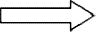

Model Training Layer-:
  - Machine Learning Algorithm (eg Logistic Regression , random Forest, XGBoost) are trained using training data.
  - The dataset is split in to training and testing sets to evaluate performance.

Prediction Layer-:
  - The trained model predicate the outcome (Diabetic/Non– Diabetic) based on new input data.

Evaluation Layer-:
- Model performance is metrics such as Accuracy , Precision , Recall and F1-Score.
- A confusion matrix used to visualize results.

User Interface Layer (optional)-:
  - A simple web approve Python–Based interface allows user to input their medical data and get predictions.

[User Input]

[Data Pre-processing]

[Machine Learning Model]

[Prediction Output] [Result Display : (Diabetic / Non-Diabetic)]

1.1 Fig - System Architecture Diagram

End
Diabetic Result (Diabetic/Non-Diabetic)
Make Prediction (Input new user data)
Evaluate Model (Accuracy,Precision etc)
Train ML Model (Logirithmic Regression)
Split Data (Train/Test)
Data Preprocessing (Handle missing values, Scaling , cleaning)
Collect Dataset
Start

2.3 Flowchart-:
The flowchart represents the working of the diabetes prediction system. The process begins with data collection, followed by preprocessing to remove missing values and normalize the data. The dataset is then split into training and testing setsThe machine Learning model is trained and evaluate using performance metrics. Finally , the trained model predicts whether a person is diabetic or not based on input medical data.

1.2 Fig–Flowchart diagram of Machine Learning

2.4 UML DIAGRAMS-:
UML stands for Unified Modeling Language. UML is a standardized general purpose modeling language in the field of object-oriented software engineering.The standard is managed, and was created by, the Object Management Group.The goal is for UML to become a common language for creating models of object oriented computer software.In its current form UML is comprised of components:a Meta
- model and a notation. In the future , some form of me to process may also be added to ;or as sociated with,UML.The Unified Modeling Language is a standard language for specifying, Visualization, Constructing and documenting heart if acts of software system, a
swellas for business modeling and other non-software systems.The
UMLrepresents a collection of best engineering practices that have proven successful in the modeling of large and complex systems.
The UML is a very important part of developing objects oriented software and the software development process.
User

- Upload / Input Data
- Train ML models (LR , RF , XGB , SVM , KNN)
- Evaluate Accuracy
- Predict Diabetes Status

Diabetes Prediction System

1.3 Fig – UML Case Diagram

3.1 Tools & Technology Used
Chapter- 3
Implementation

The development of the diabetes Prediction System was carried out using various tools,technologies,and libraries that enabled efficient data processing , model training and evaluation.

Category | Tool / Technology | Description / Purpose
Programming Language | Python | Primary language used for machine learning, data processing, and model implementation.
Development Enviorment | Google Colab / Jupyter Notebook / VS Code | Used for writing,executing, testing Python code  interactively.
Libraries Used | NumPy , Pandas, Streamlit | For data visualization ,plotting graphs and Frontend Graphical  User Interface.
 | Sckit-learn (sklearn) | Core machine learning usedfor mode building ,training and evaluation (Logistic Regression , Random Forest , KNN ,SVMetc)
 | SVM  Support Vector Machine | Algorithm used for high performance and Prediction
Dataset | PIMA Indian Diabetes Dataset (Kaggle) | Standard dataset containing medical records of women for diabetes prediction.
Operating System | Window / Linux | Compatible OS platform For python development.
1.4 Fig - Tools & Technologies

Proposed Methodology

This study aims to propose an model for diabetic’s classification. Numerous algorithms and different approaches have been applied,
such as traditional machine learning algorithms,ensemble learning approaches and association rule learning in order to achieve the best classification accuracy.The methods employed in this research are split by thefour main phases of theres earch work, which are the problem formulation phase, the dataset collection phase, and the experimentation phase and the results summarizing.
This research started with formulating the research problem that is reviewing of the literature and formulating of the research problem.After the research problem formulation ,this research identified the scope of the research, the objectives, and limitations of the research procedure. The second phase of the study is the dataset collection. The dataset items were collected from National Institute of Diabetes and Digestive and Kidney Diseases. The third phase of the study was the data preparation which included:
Converting Data Appropriate format-:
    - Data Pre-processing
    - Use Machine Learning to manipulate
    - Data In the experimentation phase several experiments were conducted and results were collected

DATASET
Dataset has been obtained from the National Institute of Diabetes and Digestive and Kidney Diseases. Diabetes dataset has 9 attributes in total.
.The dataset contains 768 records of female patients. Diabetes dataset has 9 attributes in total. All the person in records are females and the number of pregnancies they have had has been recorded as the first attribute of the dataset. Second is the value of glucose Level and then is the blood pressure (mm Hg), fourth inline is the Triceps skin fold thickness (mm), then is the 2-Hour serum insulin (mu U/ml), sixth is Body mass index (weight in kg/ (height in m) ^2) and then seventh is the Diabetes pedigree function and the second last value is the that of the Age (years).

Sr. Number | Attributes
I | Pregnancy
II | Glucose Level
III | Blood Pressure
IV | Skin Thickness
V | Insulin Level
VI | BMI (Body MassIndex)
VII | Diabetes Pedigree Function
VIII | Age

1.5 Fig–Diabetes Prediction Dataset Attribute

    - Pregnancies :Those who develop gestational diabetes are athigher risk of developing type 2 diabetes later in life.The subjects with more number of pregnancies have a higher risk of developing diabetes.

    - Glucose : The subjects were given an oral glucose test, whereby, they were administered glucose and a reading of their plasma glucose concentration was taken after 2 hours. The subjects with higher levels of glucose concentration after 2 hours have a higher risk of developing diabetes.
    - Blood Pressure : Having blood pressure over140/90mm Hg of Mercury are linked to having increased risk of developing diabetes. Although, certain subjects having diastolic blood pressure 70 mmHg may develop diabetes.

    - Skin Thickness :Skin thickness is primarily determined by collagen content and is increased in the case of insulin dependent diabetic patients. The subjects’ tricep skin fold were measured and results showed that having a skin thickness of 30mm of greater are at a higher risk.

    - Insulin : Normal insulin levels after 2 hours of glucose administration is16-166ml U/L.Subjects having loweror higher levels than said value are at a higher risk.

    - Body Mass Index (BMI) : Subjects having a BMI over 25 have a relatively Sr. Number Attributes I Pregnancy Attribute II Glucose Attribute III Blood Pressure Attribute IV Skin thickness Attribute V Insulin Attribute VI Body Mask Index VII Diabetes Pedigree Function Attribute VIII Age Criteria Diabetes Prediction Using Machine Learning Dept of CSE, SSGMCE, Shegaon (Session: 2022- 23) 13 high risk in having diabetes.

    - Diabetes Pedigree Function : The diabetes pedigree function provides “a synthesis of the diabetes mellitus history in relatives and the genetic relationship of those relatives to the subject.” The higher the DPF, the more likely it is for a subject to be diabetic.

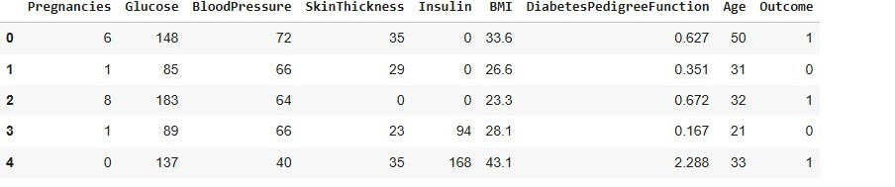
    - Age: Diabetes is prevalent in any age group, but is commonly foundin middle aged adults (45 onwards). Taking that into consideration, subjects with in the higher age group have a higher expectancy of diabetes.
  - Fig– Diabetes Prediction Dataset.

Distribution of Diabetic Patient -: In our attempt to develop a

Diabetes prediction
model we encountered a slightly disturb

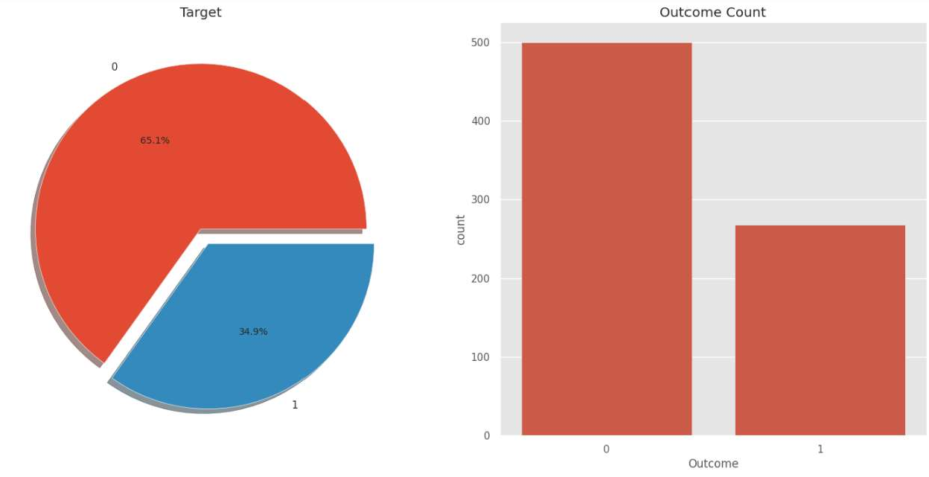dataset. Out of the total 768 samples, around 500 were Designated as 0, denoting the non existence of diabetes., while 268 were designated as 1, denoting the existence of diabetes.

1.7 Fig–Distribution of dataset for Diabetic / Non–Diabetic Patient

DATA PRE-PROCESSING
Data preprocessing is a process in which that is actual use for converting the basic data in to the clean dataset.It is the step in which the data transform or an encode to the state that the machine can be easily parse. The major task of data pre-processing in learning process is to remove the unwanted data and filling the missed value.So that it help to machine can be trained easily.

Data Integration
Data Cleaning
Data Transformation
Data
Pre-Processing
Data Reduction or Dimension Reduction

1.8 Fig– Data Pre-Processing

Chapter -4
Model Evaluation

  - Model Selection & Training

    - Logistic Regression-:
Logistic regression is a machine learning used when dependent variables are able to categorize , The outputs obtained by using the logistic regression is based on the available features.Here sigmoidal function is used to categorize the output.

K-Nearest Neighbors-:
K-Nearest Neighbors (KNN) algorithm uses ‘Feature similarity’ to predict the values of new data points which further means that the new data point in the training set.
Predictions are made for a new instance(x) by searching through the entire training set for the K-most similar instances (the neighbors) and summarizing the output variable for those K instances.

SVM (Support Vector Machine)-:
SVM is supervised learning algorithm used for classification .In SVM we have to identify the right hyper plane to classify the data correctly .In this we have to set correct parameters values. To find the right hyperplane we have to find right margin for this we have choose the gamma value as 0.0001 and rbf kernel . If we select the hyperplane with low margin leads to miss classification.

Random Forest-:
Random Forest is an ensemble learning method for classification. This algorithm consist of trees and the number of tree structures present in the data is used to predict the accuracy. Where leaves are corresponds to the class labels and attribute are corresponds to on ternal node of the tree . Here number of trees in forest used is 100 in number and Gini index is used for splitting the nodes.

XGBoost-:
XGBoost ( extreme Gradient Boosting) is one of the most powerful and widely used machine learning algorithms – especially for classification and regression problems like your diabetes Prediction. It is an optimized implementation of the Gradient Boosting algorithm,It builds ensemble of decision trees,where each new tree corrects the errors made by the previous ones.

4.2.Accuracy Score-:

Machine Learning Algorithm | Result
SVM | 78.0
Random Forest | 78.4
XGBoost | 79.0
KNN | 76.6
Decision Tree | 75.0

  - Fig–Accuracy Table

4.3.Precision , Recall , F-1 Score-:

Metrics | Your Value
Precision | 66.0
Recall | 75.68
F-1Score | 61.54
1.10 Fig– Precision, Recall, F-1 ScoreTable

Chapter– 5

Prediction
- The trained model predicts the outcome 1=Diabetic,
- 0 = Non- Diabetic based on user input values.
- Prediction are displayed through the interface or
console Output
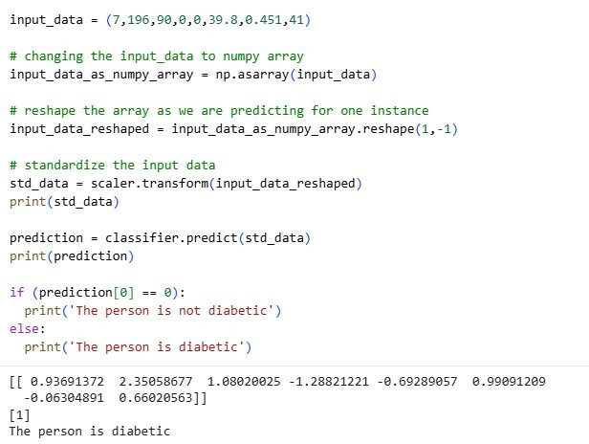

1.11 Fig– Prediction for Diabetic / Non-Diabetic

Chapter- 6

Results & Discussion
The table below displays the performance values of various classification algorithms, calculated using different measures. Based on the table, it is observed that Logistic regression exhibits the highest accuracy.Therefore, the Logistic regression machine learning classifier is capable of predicting the likelihood of diabetes with greater precision than other classifiers.

Accuracy Score-:

Machine Learning Algoriithm | Result
SVM | 78.0
Random Forest | 78.5
XGBoost | 79.0
KNN | 76.0
Decision Tree | 75.0
1.9 Fig– Accuracy Table
So with the help of above mentioned procedure, we have completed our project named as Diabetes Predication System using Machine Learning to improve diabetes detection process using machine learning. In this project, the data was formulated in different formulations and the model (SVM ) was trained with above 78 % acuracy.

Chapter–7

CONCLUSION

The proposed project on Diabetes Prediction using Machine Learning Demonstrates the potential of data-driven models in assisting healthcares system to identify individuals at risk of diabetes at a an early stage.By analyzing medical parameters.

Such as Pregnancies , Glucose Level , Blood Pressure , Skin Thickness
, BMI , Diabetes Pedigree Function , Age.Machine Learning algorithms can provide reliable predictions that supporttimely diagnosis and intervention.

The Project Highlights the advantages of integrating computational intelligence into the medical domain, offering accuracy , efficiency and scalability compared to conventional methods. Although the system does not replace professional medical judgement, it can serve as an effective decision-support tool for healthcare providers.

Overall the project emphasizes that predictive analytics in healthcare can reduce the disease burden ,improve patient outcomes, and guide preventive strategies. Future improvements may include expanding the datsset , integrating the model into real healthcare applications for wide accessibility.

      - The Project aims to develop a machine learning – based system for predicting diabetes, addressing the need for early detection and intervention.

      - The proposed approach uses various classification and ensemble learning method in which SVM classification used and achieved 78.0 % accuracy has been achieved.

FUTURE SCOPE

In future, we will try to create a diabetes dataset in collaboration with a hospital or a medical institute and will try to achieve better results. We will be incorporating more Machine Learning and Deep learning models for achieving better results as well .

For later work It is far vital to conduct in hospitals actual and newest sufferers Information for regular instructing and development of our present model.
The amount of the data item has massive sufficient for education and forecasting. Some further methods and portraits need to take a look of DM (data mining).
To expand a chain of regulation and quality approach to stop human beings from come out of data mining.
It assists to minor the increase price of blood glucose and subsequently reduce the danger of forecasting data mining.

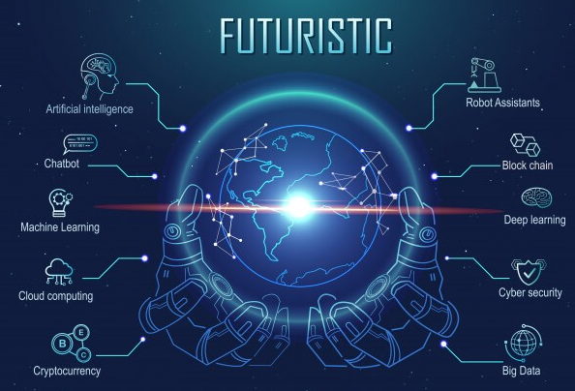

  - Fig–Future Steps for Machine Learning Models

Chatpter-8
Result of Prediction

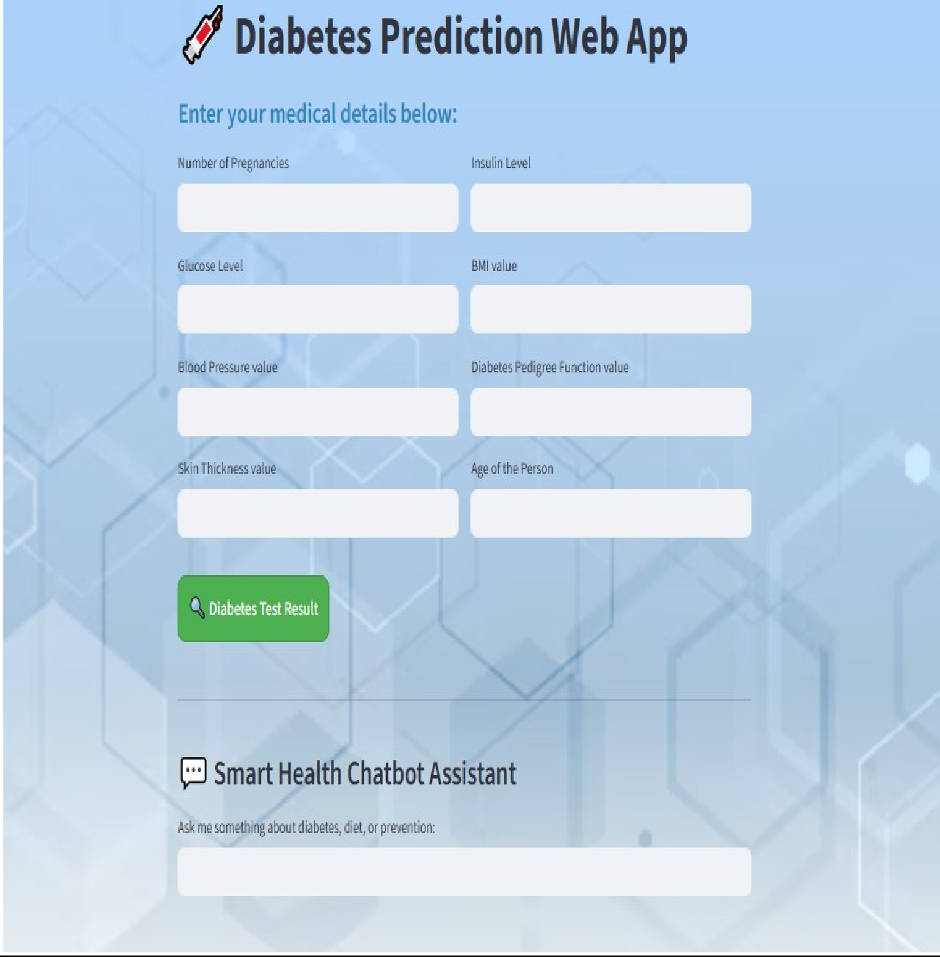

Fig- Homepage of Diabetes Prediction Model

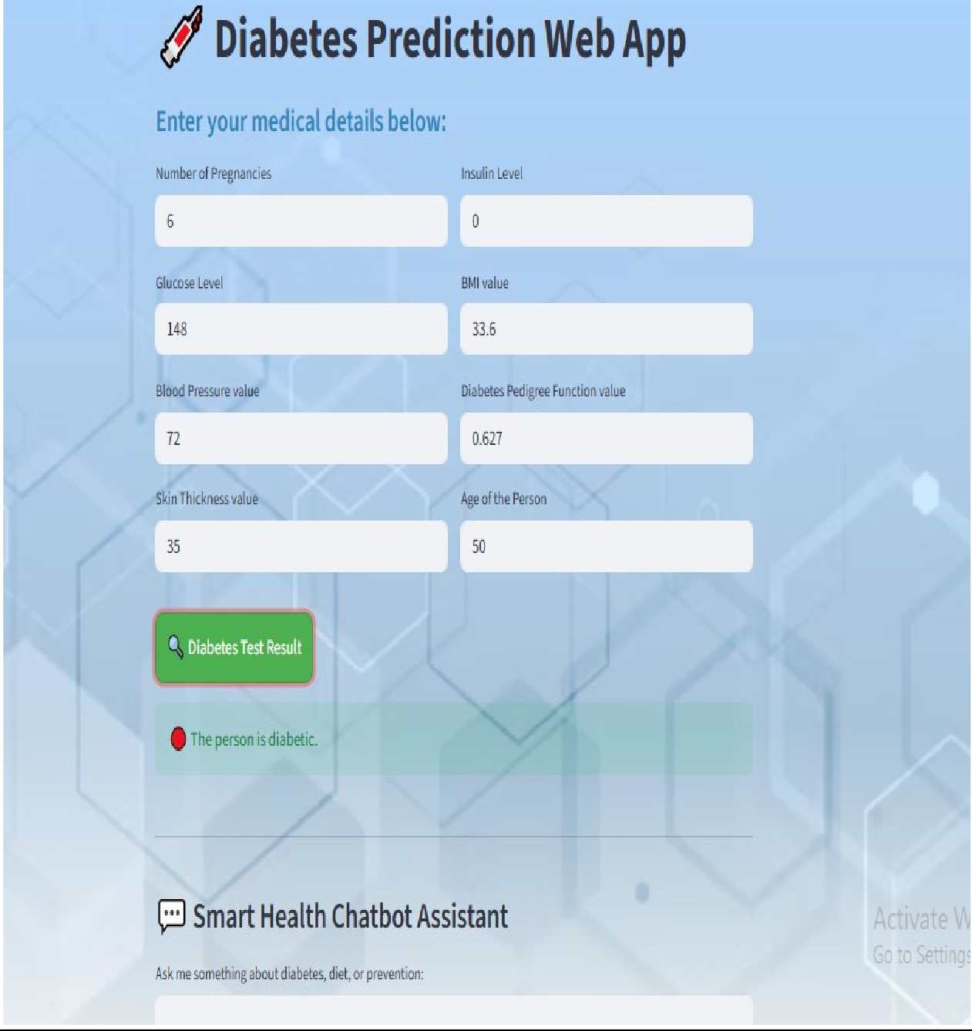

  - Fig– Result of Prediction (Diabetic)

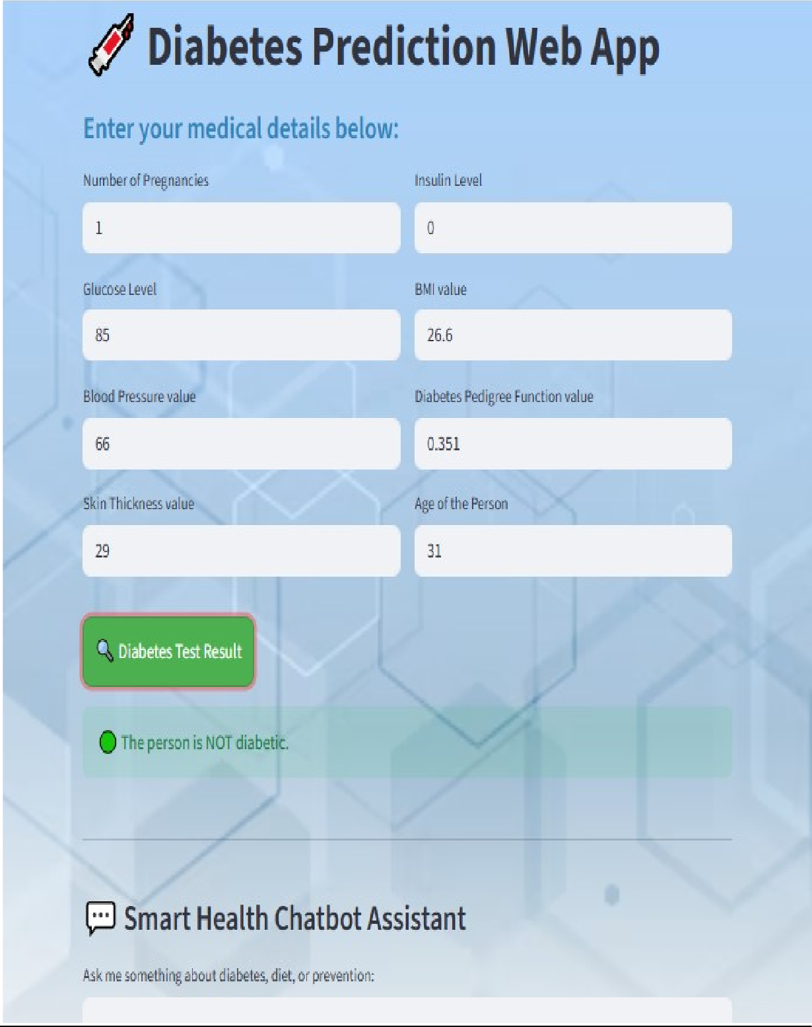

1.15 Fig– Result of Prediction (Non–Diabetic)

Chapter-9

References (In APA Style)
- Dua,D.,&Graff,C.(2019).UCI Machine Learning Repository : Pima Indians Diabetes Database. Universityof California, Irvine, School of Information and Computer Sciences. Retrieved from https://archive.ics.uci.edu/ml/datasets/diabetes
- Kumar, V., & Singh, D. (2020). Diabetes prediction using machine learning algorithms.International Journal of Computer Applications, 176(30), 26–29. https://doi.org/10.5120/ijca2020919978

- Patel,J.,& Gupta,K.(2021).A comparative study of machine learning techniques for diabetes prediction. International Journal of Advanced Research in Computer Science, 12(3), 45–50. https://doi.org/10.26483/ijarcs.v12i3.6748

- Choubey,D.,Paul,S.,& Yadav,S.(2022).Predictive analysis for diabetes using machine learning techniques. International Journal of Engineering Research & Technology (IJERT), 11(4), 1–6. https://doi.org/10.17577/IJERTV11IS040015

- Pedregosa,F.,Varoquaux,G.,Gramfort,A.,Michel,V.,Thirion,B.,Grisel, O., ... & Duchesnay, E. (2011). Scikit-learn: Machine learning in Python. Journal of Machine Learning Research, 12, 2825–2830. Retrieved from https://scikit-learn.org/

- Chen,T.,& Guestrin,C.(2016).XGBoost : A scalable tree boosting system. Proceedings of the 22 nd ACM SIGKDD International Conference on Knowledge Discovery and Data Mining, 785–794. https://doi.org/10.1145/2939672.2939785
- McKinney,W.(2010).Data structures for statistical computing in Python. Proceedings of the 9th Python in Science Conference, 51–56. https://doi.org/10.25080/Majora-92bf1922-00a

- Hunter,J.D.(2007). Matplotlib : A 2D graphics environment. Computing in Science & Engineering, 9(3), 90–95. https://doi.org/10.1109/MCSE.2007.55

